## 

**PROJECT REPORT**

**ON**

**ANALYSIS OF SOCIAL MEDIA**

**POWER BI**

Submitted by: Submitted to: Anjali pal Mr. Sourab Poswal sir

MBA 1 year Sec-A

CU240140559

**Project Title “CAR SALES DATA”**

**O Name of the student(s) Anjali pal**

**O Registration number(s) CU240140559**

**O Course and semester MBA 1 semester**

**O Submission date 22 November 2024**

**O Faculty/Guide name Mr. Sourab poswal sir**

**Faculty Signature -**

**EXECUTIVE SUMMARY**

This project focuses on analyzing social media users data using Power BI to provide valuable insights into the usage of social media by different individuals for various purposes. The main goal was to create a dashboard that helps us to understand the pattern of using social media.

**Key Objectives**

Understanding Usage Patterns

Demographic Analysis

Data Visualization

Engagement Insights

Content Performance

**METHODOLOGY**

1. Data Collection
2. Data Modeling
3. Data Visualization
4. Analysis
5. Insights Generation
6. Reporting
7. Review and interpret

This methodology provides a structured approach to analyzing car sales data, ensuring thoroughness and clarity in insights generated.

**Key Insights**

Time spent on social media

Addiction level by gender

User by profession

Satisfaction of users

Content preference

**Outcomes of the Analysis:** The analysis of the car sales dataset provided valuable insights into key trends, customer demographics, and regional usage. Through the use of Power BI, we were able to visualize these patterns and derive meaningful conclusions that align with the project’s objectives.

**TABLE OF CONTENTS**

1. Introduction
   * Context of the Project
   * Objectives
2. Data Overview
   * Data Sources
   * Data Description
   * Data Preparation
3. Power BI Process
   * Dashboard Design
   * Data Modeling
   * Visualizations
4. Insights and Analysis

* Key Insights

1. Business Recommendations
2. Limitations of Analysis
3. Conclusion

**INTRODUCTION**

Social media has revolutionized the way we communicate, share information, and connect with the world. Platforms like Facebook, Instagram, and Twitter have become essential tools for individuals and businesses alike. Social media has become an integral part of modern life, shaping how people interact, share information, and consume content. With billions of users across platforms like Facebook, Instagram, Twitter, and TikTok, the scope of social media usage is vast and ever-evolving.

This Power BI report provides an in-depth analysis of social media usage trends, user demographics, and platform preferences. By leveraging interactive data visualizations, the report uncovers patterns in user behavior, the rise of new platforms, and the global reach of social networks.

This project focuses on using power bi to help in analyze trend or pattern of using social media and uncover insights that can help with the content management, marketing strategies, and targeting. This project leverages power bi to develop an interactive dashboard of usage of social media data that provides real-time insights into these factors.

The importance of this project lies in its ability to transform raw data into meaningful visualizations, allowing us to make informed decision. This project empowers management to identify patterns of using social media, track type of content demographically seen. In a rapidly changing environment, understanding customer behavior and market dynamics is key to maintaining a competitive advantage.

**Objective**

The primary objective of this project is to leverage Power BI to analyze and visualize social media usage data, providing actionable insights that support strategic decision-making. Specific objectives include:

* Understanding Usage Patterns

Identify trends in user activity, such as peak usage times, engagement levels, and content consumption behavior across various platforms.

* Demographic Analysis

Examine user demographics, including age, gender, and location, to understand audience characteristics and tailor strategies accordingly.

* Engagement Insights

Analyze metrics like likes, shares, comments, and follower growth to measure audience engagement and content effectiveness.

* Content Performance

Assess which types of content resonate most with users to optimize future campaigns and improve content strategies.

* Data Visualization

Use Power BI’s interactive dashboards to present complex social media data in an accessible and visually appealing format.

* Support Decision-Making

Provide stakeholders with data-driven insights to enhance social media strategies, marketing campaigns, and user engagement initiatives.

By fulfilling these objectives, the project aims to harness the power of data analytics to maximize the effectiveness and reach of social media efforts.

**DATA OVERVIEW**

**DATA SOURCES**

Excel file (dataset) was imported from which data was sourced of an internal dealership database, containing information about cars sales data with various variables.

In a car sales analysis project, various data sources can be utilized to gather relevant information. Here’s a brief Description of each;

**Online Database:** These are cloud-based databases (such as Azure SQL Database or Google Cloud SQL) that offer scalability and accessibility. They can host real-time data that can be integrated into Power BI for dynamic reporting.

**CSV Files:** Comma-separated values (CSV) files are often used to export and import data. They are simple Text files that store tabular data and can be easily created and manipulated. CSV files might contain sales Records, customer feedback, or market research data**.**

**Excel Files:** Microsoft Excel files are commonly used for data storage and analysis. They can contain various Datasets, including sales figures, inventory lists, and performance metrics, and can be directly imported into Power BI for visualization and reporting.

**DATA DESCRIPTION**

A comprehensive dataset that includes variables such as User ID: A unique identifier assigned to each user.

1. Age: The age of the user.
2. Gender: The gender of the user.
3. Location: The geographical location of the user.
4. Income: The annual income of the user.
5. Profession: The profession or job title of the user.
6. Demographics: Additional demographic information about the user (Rural or Urban Life).
7. Platform: The social media platform used by the user (e.g., Facebook, Instagram, TikTok).
8. Total Time Spent: The total time the user has spent on the platform.
9. Number of Sessions: The number of sessions the user has had on the platform.
10. Video ID: A unique identifier for each video watched.
11. Video Category: The category of the video watched (e.g., Entertainment, Gaming, Pranks, Vlog).
12. Video Length: The length of the video watched.
13. Engagement: The engagement level of the user with the video (e.g., Likes, Comments).
14. Time Spent On Video: The amount of time the user spent watching the video.
15. Number of Videos Watched: The total number of videos watched by the user.
16. Scroll Rate: The rate at which the user scrolls through content.
17. Frequency: How frequently the user logs into the platform.
18. Productivity Loss: The amount of productivity lost due to time spent on social media.
19. Satisfaction: The satisfaction level of the user with the content consumed.
20. Watch Reason: The reason why the user watched the video (e.g., Entertainment, Information).
21. Device Type: The type of device used to access the platform (e.g., Mobile, Desktop).
22. Watch Time: The specific time of day when the user watched the video.
23. Addiction Level: The user’s self-assessed level of addiction to social media.
24. Connection Type: The type of internet connection used by the user (e.g., Wi-Fi, Mobile Data).

Overview:-no. Of rows -1000, no. Of columns-24

**DATA PREPARATION**

Data cleaning: identify and handle missing values, duplicates, and inconsistencies in the dataset to ensure data quality.

Cleaning data in Power BI involves several key steps to ensure that the dataset is accurate, complete, and ready for analysis. Here’s a typical workflow:

1. Import Data: Load your data from various sources (e.g., Excel, CSV, databases) Into Power BI.
2. Open Power Query Editor: Access the Power Query Editor, where you can perform data transformation and cleaning tasks.
3. Remove Unnecessary Columns: Identify and remove any columns that are not needed for analysis, which helps streamline the dataset.
4. Filter Rows: Apply filters to remove any irrelevant or erroneous rows, such as Duplicates or outliers.
5. Handle Missing Values: Identify missing data and decide how to handle it. You can fill in missing values, replace them with default values, or remove the affected Rows.
6. Change Data Types: Ensure that each column has the correct data type (e.g., Text, number, date). This step is crucial for accurate calculations and visualizations.
7. Trim and Clean Text: Remove leading or trailing spaces from text fields and Correct any inconsistencies in formatting (e.g., case sensitivity)
8. Merge and Append Queries: If necessary, combine multiple datasets (merge) or Add rows from different sources (append) to create a unified dataset.
9. Create Calculated Columns: If needed, create new columns based on existing Data for better insights (e.g., categorizing sales into ranges).
10. Rename Columns: Use clear and meaningful names for columns to make your

Dataset easier to understand.

1. Check for Duplicates: Identify and remove duplicate records to ensure data

Integrity.

1. Sort and Organize Data: Organize the data for better readability and Accessibility, ensuring that it meets your analysis needs.
2. Load Cleaned Data: Once the data is cleaned, load it back into Power BI for Analysis and visualization.

By following these steps, you can ensure that your data is reliable and ready for Insightful analysis in Power BI.

**POWER BI PROCESS**

The Power BI dashboard for the Usage of social media Data Analytics project is structured into two pages, serving a unique analytical purpose. This layout ensures a clear separation between key Metrics, detailed insights of content type seen, profession of users and total time spent etc. Below is an Explanation of the layout, design choices, and user interactions:

KPIs PAGE: HIGH-LEVEL OVERVIEW

Purpose: This page provides a high-level summary of the most important key performance Indicators (KPIs) to offer immediate insights into overall business performance.

KPIs Displayed:

1. Total time spent: it shows the total amount of time spent on social media.
2. Average scroll rate: it shows average scroll rate of the user across different locations.
3. Number of users: it shows the number of user engaged in social media platforms from different region or location.
4. Number of videos watched: it shows total number of videos watched by individuals.
5. Latest watch time: it shows the latest time at which users are engaged in the social media.

**Design**

• Tile Format: Each KPI is displayed in a clean and concise tile format for quick Viewing. These tiles are shown to highlight performance metrics.

• Interactivity: This page does not include detailed interactivity but offers an at-a-glance Understanding of key metrics that executives or stakeholders can reference.

USER INTERACTIONS ACROSS PAGES

Each page of the dashboard allows users to interact with slicers, filters, and clickable visuals. This interaction enhances the dashboard experience by allowing users to filter by:

* Total time spent
* Average scroll rate
* Number of users
* Latest watch time
* Number of videos watched
* Location

**DASHBOARD DESIGN**

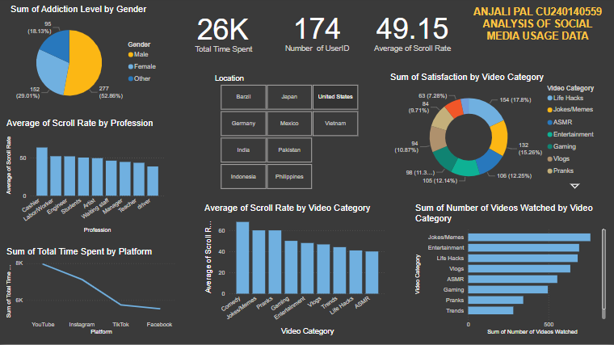

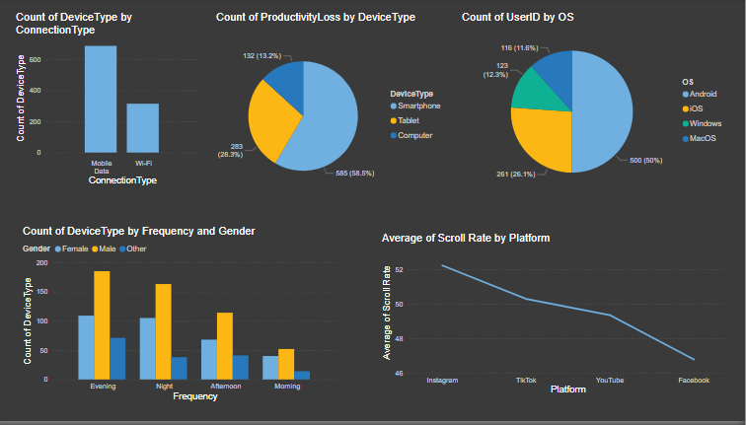

**DATA MODELING**:

Data modeling in Power BI involves designing and creating relationships between data tables to enable efficient analysis and reporting. It is the foundation for building dynamic and interactive dashboards.

Measures: Measures are calculations used for aggregations or Summaries, dynamically evaluated based on the context (e.g., Total Sales, Average Quantity).

Data Types: Ensuring correct data types (text, numbers, dates, etc.) Is critical for accurate calculations and relationships in the model.

Primary Key: A unique identifier for a record in a table e.g., User_ id

**Visualization**

1. **KEY PERFORMANCE INDICATORS (KPIS)**

* Description: Cards displaying metrics such as Total time spent, Count of user id , number of video watched, average scroll rate and latest time spent.
* Reason for Use: KPIs provide a quick snapshot of essential metrics, allowing stakeholders to assess business performance at a glance. They are straightforward and emphasize critical data points, making them easy to understand.

1. **PIE CHART**

* Description: A pie chart illustrating the addiction level by gender, USER ID by OS, and productivity loss by device type.
* Reason for Use: Pie charts are useful for showing the proportion of parts to a whole. They visually emphasize the composition of the company base, making it easy to see demographic trends.

1. **SLICERS**

* Description: A slicer allowing users to filter data by region, so they can examine the usage of specific geographic areas.
* Reason for use: A slicer in Power BI is used to filter data interactively, allowing users to refine and control the visualizations on a report page based on specific criteria, such as categories, dates, or custom selections.

1. **COLUMN CHART**

Column charts in Power BI are a great way to visually represent categorical data. They allow you to compare different categories or track changes over time.

1. **CARD**

In power BI, cards are a type of visual used to display key Metrics or single data points. They provide a simple and effective Way to present important information at a glance

1. **DONUT CHART**

It is often used to represent proportions of a whole, making it easy to compare relative contributions of different categories. It is best to use them with a small number of segments (around 5–6 categories).

1. **STACKED COLUMN CHART**

A **stacked column chart** is a type of chart that is used to display the total of different categories and how each part (or segment) contributes to the whole. It is especially useful when you want to compare multiple categories across different groups or time periods while also highlighting the individual contributions to the total.

1. **CLUSTERED COLUMN CHART**

A **clustered column chart** is very similar to a clustered bar chart but with vertical bars instead of horizontal ones. It is used to display and compare data across different categories, where each category can have multiple sub-categories or groupings. The clustered column chart allows for a side-by-side comparison of the sub-categories for each main category.

1. **CLUSTERED BAR CHART** A clustered (or grouped) bar chart is a type of bar chart where multiple bars representing different categories are grouped together, allowing for easy comparison of data across multiple categories or sub-categories

**INSIGHT AND ANALYSIS**

Based on the detailed analysis of the social media usage data, several key insights were uncovered that align with the project objectives of identifying top used platform , user preference, user demographics, platform preferences, scroll rate and device specifications. These insights are derived from the various Power BI visualizations and metrics:

* Platform preference: The analysis of the platform used revealed that TikTok was the platform that is max used. **TikTok has 27.28**%of total users. This is significantly higher than other social media platforms like **Facebook** or **Instagram**, YouTube indicating its highly engaging content and algorithmic feed that encourages longer interaction
* Content preference: Top content or video category with the highest satisfaction, demonstrating its Dominance in the market. Video category “**Jokes and memes**” had the highest preference volume of **17.04%,** showing the best performance Compared to other category. Jokes and memes often appeal to the **curiosity** of users.
* Scroll rate: **labor /workers** were the most popular profession engaged in scrolling, Accounting for a majority of the scroll rate indicting 55.46 (average), pranks category indicating 55.14 (average) and Instagram indicating 52.23(average). This trend aligns with the growing global Preference for Instagram platform used for scrolling.
* OS Preference: A**ndroid** holds a larger global share of **50% users** using Android, especially in emerging markets, due to its **affordability** and **variety of device options**.
* Connection: **Mobile data** holds a larger share in usage of data than Wi-Fi indicating 686 users using mobile data and 314 users using Wi-Fi .
* Addiction: the analysis of data describes that **Males** are more addictive to social media platform then Females indicating **52.44%** addiction, females indicating 32.21%and other indicating 25.35%.

**BUSINESS RECOMMENDATION**

* Optimize Content Strategy

Focus on the types of content (e.g., videos, images, and info graphics) that drive the highest engagement based on platform usage insights.

* Target Audience Effectively

Leverage demographic data to tailor content and campaigns for specific age groups, regions, or interests to maximize reach and impact.

* Invest in High-Performing Platforms

Prioritize platforms with the highest user activity and engagement rates for marketing and advertising efforts.

* Enhance Posting Schedules

Use time-based analysis to determine peak activity periods and schedule posts accordingly to improve visibility and interaction.

* Monitor and Mitigate Negative Feedback

Identify and address negative trends, such as customer complaints or low engagement, to protect brand reputation.

* Boost Customer Interaction

Increase responsiveness by analyzing response times and user interactions, ensuring timely communication with the audience.

* Measure Campaign Effectiveness

Regularly review key performance indicators (KPIs) like clicks, conversions, and ROI to refine marketing strategies and allocate budgets more efficiently.

* Address Privacy Concerns

Use data responsibly and transparently to build user trust and comply with legal regulations on data protection.

* Adapt to Emerging Trends

Stay agile by monitoring platform usage trends and new social media tools, ensuring relevance in a competitive digital landscape.

By implementing these recommendations, businesses can maximize their social media presence, enhance customer engagement, and drive measurable results.

**LIMITATIONS**

* Data quality and availability: Incomplete or inconsistent sales data from multiple sources can skew results, and external factors like market trends may be missing.
* Real-time data processing: Power bi is not ideal for real-time analytics, leading to delays in refreshing sales data.
* Complex data models: Large datasets can complicate data models and slow report performance.
* Limited advanced visualizations: Power bi has basic visualizations, and complex or custom visuals may require external tools.
* Mobile Experience: The mobile version of Power BI, while functional, may not fully support all features and visualizations found in the desktop version, leading to a suboptimal user experience on smaller devices.

**CONCLUSION**

This project involved the development of a comprehensive power bi dashboard designed to analyze car sales data. The dashboard included various visualizations, cards, and slicers, providing a dynamic and interactive way to explore and understand key usage metrics. By systematically analyzing the data, the dashboard revealed several significant insights that have the potential to influence business strategies and decision-making processes. Here are some of the key takeaways:

**Platform Dominance and Preferences**.

**Content Types and Engagement**

**User Behavior and Expectations**

In conclusion, the usage of social media has become an essential component for businesses, individuals, and organizations to engage with their audience, build brand awareness, and drive growth.

.